Initial Project Proposal

Year: 2022 Semester: Fall Project Name: Hermes (Placeholder)

Creation Date: ­June 4, 2022 Last Modified: June 18, 2022

Team Members (#1 is Team Leader):

Member 1: Michael Langford Email: mjlangfo@purdue.edu

Member 2: Jonathan Wosiak Email: jwosiak@purdue.edu

Member 3: Owen Mandel Email: omandel@purdue.edu

Member 4: Santiago J Garcia Delgado Email: garciads@purdue.edu

1.0 Description of Problem:

Search and rescue operations are required to ensure the safety of individuals who are in imminent danger. These rescue operations often occur over a wide variety of hazardous terrain, that could put additional people in harm’s way to safely recover the person in imminent danger. The possibility of saving the person’s lives in these situations also depends on finding these people as soon as possible. The people who undergo these operations often put their own lives on the line to ensure the safety of others, and although this is admirable, a better, safer, and faster solution is required.

There are numerous situations where search and rescue (SAR) operations are impossible or made prohibitively time-consuming or dangerous due to the nature of the size and or impassibility or terrain. While solutions exist that are human controlled, it is not apparent that a commercial solution with true autonomous operation exists for SAR purposes.

Itemized issues:

* Coverage of large amounts of terrain quickly during search/rescue
* Navigation through complex and dangerous/impassable terrain
* Identification of destination via GPS AND image recognition
* the accomplishment of these goals above autonomously, via identification of obstacles

2.0 Proposed Solution:

The team proposes the use of an autonomous quadcopter drone for remote emergency response/search and rescue. Our autonomous drone would be sent to work in a selected area and should search for injured persons within the selected areas. This autonomous drone would communicate the location through a radio signal for search and rescue workers to go in and recover the person the drone found.

This drone would have GPS and computer vision to able to maneuver dangerous terrain to find injured individuals. In its first iteration Hermes should only be able to find injured people and send that information back to the search and rescue teams, however additional functionality could be added by providing first aid, rope, etc. to injured/stranded individuals through Hermes. This could be done by giving Hermes a claw and allowing it to drop it near the injured individual.

This drone would solve the issues of traversal of impassible or prohibitively dangerous terrain, as well as enable search and rescue operations over larger amounts of land.

Use case example – rescue operations within non-navigable terrain such as the Subway within Zion Natl. Park. There are numerous canyoneering routes in that area that rescue is very difficult within, particularly if the subject has not yet been located. A drone such as this could navigate the complex canyon route and locate those in need of rescue, saving precious time for the rescue team and allowing them to plan an effective approach to the subject.

Summary - Drone using custom flight controller for aerodynamic stability and GPS/stereo vision for autonomous GNC and obstacle avoidance, intended for use as emergency response/search and rescue over dangerous terrain.

Solution satisfies following needs:

* Drone based search / identification platform
* Capable of coverage of rough or impassable terrain
* Capable of search in remote areas over large areas of terrain
* Can avoid hazards dangerous to humans
* Autonomous

Implementation Details:

* Quadcopter based drone
* Brushed motors
* Electronic speed controllers
* Custom flight controller for essential stability and navigation controls
* Image recognition and navigation platform using raspberry pi and stereo vision with GPS

*Flight controller level block diagram:*

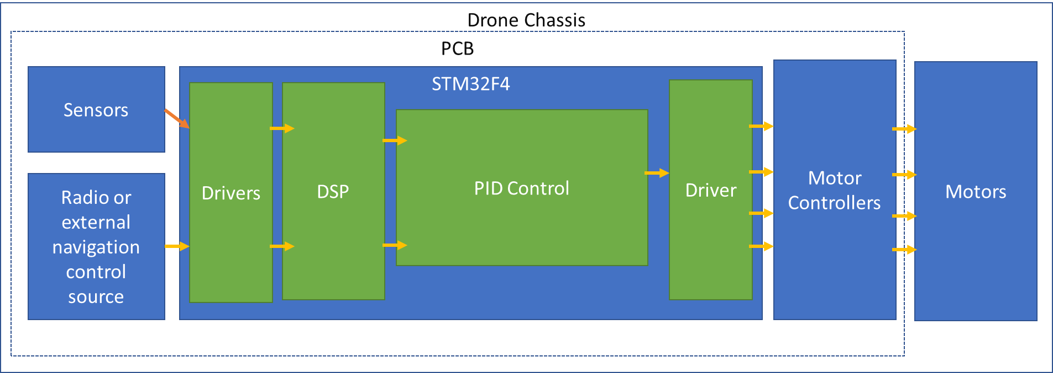

GNC level block diagram

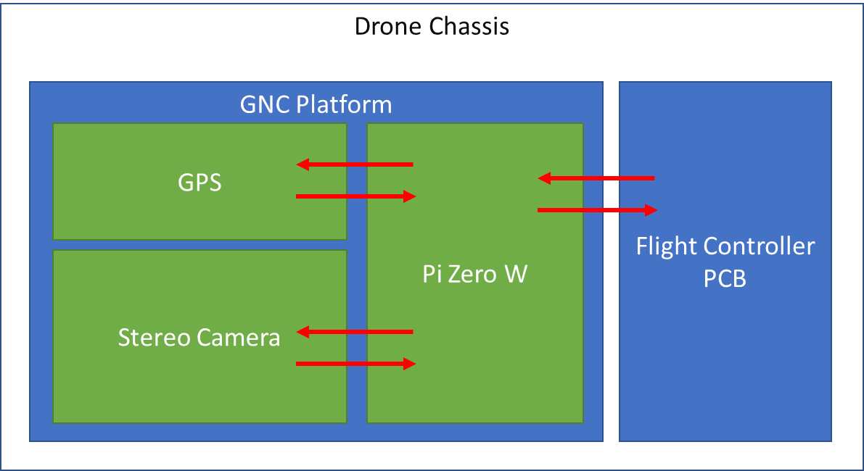

3.0 ECE477 Course Requirements Satisfaction

3.1 Expected Microcontroller Responsibilities

ECE477 is an embedded systems course which requires the use of a student-programmed microcontroller. For the project proposed, a microcontroller will be used to control navigation and stability sensor polling via a protocol like SPI or I2C,managing the stability control loop (PID), radio control, motherboard communication (with the Raspberry Pi listed below), motor controller communication and hardware monitoring. Future possible additions for the microcontroller to accomplish would be camera gimbal control. Along with the student-programmed microcontroller, a motherboard, in particular, a Raspberry Pi, will be used to do GPS navigation, stereo camera control and image acquisition, along with image processing for identification, and object detection, with the motherboard able to communicate with the daughter board that houses the student-controller microcontroller.

Expected microcontroller tasks

* Navigation and Stability sensor polling via SPI / I2C
* Stability control loop (PID)
* Radio control
* Motherboard (GNC system) control communication
* Motor controller communication
* Hardware monitoring
* (possibly) camera gimbal control

Expected Pi (separate from stability microcontroller) tasks

* GPS Navigation
* Stereo camera control and image acquisition
* Image processing and identification
* Object detection & avoidance
* Daughterboard (Stability micro) communication

3.2 Expected Printed Circuit Responsibilities

ECE477 is an embedded systems course which requires the use of a student-designed and built printed circuit board (PCB). For the proposed project, the PCB is expected to incorporate sensors such as a gyroscope, accelerometer, barometer and magnetometer, a USB interface, test points, I2C interface, SD card or SPI flash, a wireless interface through either a Pi wireless or ESP866 or another similar device, and an interface to GNC board that utilizes the Pi. Other functionality may be included as the ECE477 design semester progresses.

PCB for flight controller subassembly

* Gyro / Accelerometer / Barometer / Magnetometer
* USB interface
* Test points
* I2C interface
* SD card / SPI flash
* Interface to GNC board using Pi
* Either Pi wireless or onboard wireless interface using ESP866 or similar

4.0 Market Analysis:

Upon market analysis, it is not apparent that there is a solution satisfying the solution set previously described at a high enough stage of development to be used operationally, however there has been a massive amount of investment and growth in this area as of late. In terms of market size, Fortune Business Insights noted that *“*The global unmanned aerial vehicle market size was valued at $10.72 Bn in 2019 & is projected to reach $25.13 Bn by 2027” [1]. Companies have been trying to break into the autonomous drone market space for years*.* One of the earliest attempts was by Amazon for their Prime Air, projects followed by Alphabet, FedEx, Uber, Microsoft, Facebook, Apple, IBM, Walmart, UPS, and more. This can be explained by the simple fact that virtually every operation that involves moving from point a to point b could benefit from an autonomous drone engineered for that operation. However, in the area of SAR, the situation is not so simple, as points a and b are unknown, and the terrain and conditions significantly more complex, and the missions inherently are no-fail. While there are examples in the SAR and similar markets, most do not cover the full spectrum of the solution criteria identified; most solutions in the SAR or similar market areas / applications are not entirely autonomous and require significant human control. While there is significant development and investment, there is clearly opportunity to advance the capabilities of SAR teams with emerging drone technology.

5.0 Competitive Analysis:

5.1 Preliminary Patent Analysis:

Drones in recent years have been growing in popularity over the past decade and there is a lot of prior art in the field of autonomous drones. There is also some relevant intellectual property in the field relating to different methods in autonomous drone navigation, described below.

**5.1.1 US Patent Application US 20170270805A1**

**Patent Title: “Systems and Methods for Autonomous Drone Navigation”**

**Patent Holder: Wal-Mart Stores, Inc.**

**Patent Filing Date: March 21, 2017**

This patent [2], assigned to Wal-Mart, details the methods for autonomous drones to navigate structures with blueprints and computer vision. This patent is specifically designed for drones inside of buildings and blueprints unlike ours which uses GPS, so our proposal would not infringe this patent. The advantage of this method is that it can be used to quickly examine small areas inside buildings. However, the problem with this method is that in search and rescue operations this wouldn’t be able to search large swaths of land like our project proposes.

5.1.2 US Patent Application US 10216181B2

**Patent Title: “Implementation of Rescue Drone”**

**Patent Holder: International Business Machines Corporation**

**Patent Filling Date: December 20, 2017**

This patent [3], assigned to IBM Corporation, explains methods for using an autonomous drone to get to the nearest emergency response location the location of an injured individual after they’ve been injured. The advantage of this method is that it informs the proper authorities about the location of an injured individual and their vitals. This is a good system for informing the proper authorities of the location of a person in danger. However, this would require individuals to carry the drone with them and it to be functional after they’ve been injured. We wouldn’t be infringing on this patent because we would want our drone to function to search for injured persons and work in conjunction with rescue teams.

**5.1.3 US Patent Application US 20170088261A1**

**Patent Title: “Search and Rescue UAV System and Method”**

**Patent Holder: “Tyco Fire & Security, GmbH”**

**Patent Filing Date: September 29, 2015**

This patent [4], assigned to Tyco Fire, describes how to have autonomous search drones to detect survivors and send messages back to a command center. This patent details how an autonomous drone is sent out in areas where there are known people in danger and searches for them, when they are found it sends information about their condition, and their location. This system is very similar to ours and there is potential for patent infringement; a patent lawyer should be consulted for a legal analysis.

5.2 Commercial Product Analysis:

Specific products used for search and rescue are not commonly marketed commercially. Retail customers are unlikely to make the hefty investment necessary for a specialized product that they are not likely to use regularly or for its intended use at all. As a result, we have compiled a list of some of the most relevant products available, with most consumer-focused products requiring some modifications to be effective at search and rescue.

5.2.1 “Matrice 210 Public Safety Thermal Kit”

Starting at $16,499, the Matrice 210 Public Safety Thermal Kit is commonly used by and marketed towards first responders. It has both autonomous and FPV modes, an IP43 rated body, utilizes a dual-battery system with a maximum flight time of 38 minutes (no payload), a maximum flight speed of 51.4 mph, and a maximum payload capacity of 4.41 lbs. with multiple payload configurations depending on the task. It utilizes dual gimbals with thermal imaging for search and rescue. 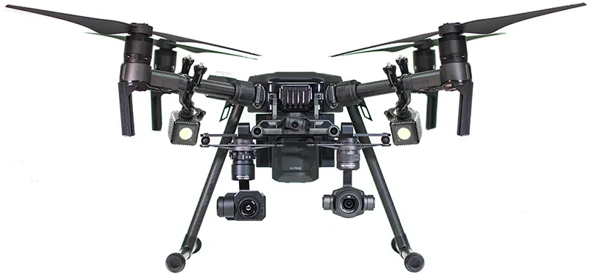

* <https://www.dslrpros.com/matrice-210-first-responder-thermal-kit.html>

5.2.2 “Skydio Public Safety Drone”

The Skydio Public Safety Drone is marketed solely towards first responders with a price of $12,998 per system. In a law enforcement capacity, it is used for situational awareness, quicker response, and improved scene documentation. In fire and rescue it is used to gain an aerial insight to improve safety, response, and rescue. The drone has 35 minutes of battery time, has a range of 6 km at 5GHz or 10 km at 1.8 GHz and utilizes a 4k60p HDR camera at 46 degrees HFOV and 16x zoom and a 320p FLIR thermal with 8x zoom.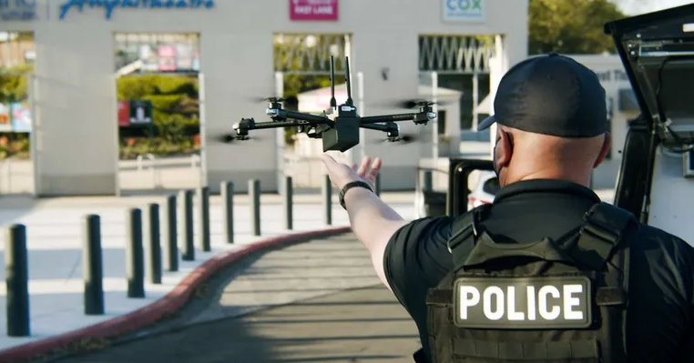

* <https://www.skydio.com/public-safety?utm_source=google&utm_medium=cpc&utm_campaign=g_s_nb_ent_sled-v2_sled_law&gclid=CjwKCAjwnZaVBhA6EiwAVVyv9B4V1Y0SvEx7siNjABH5mJDT6fUVjzdlZ21W_q4qU_EDMGhaPkwL_RoCOQsQAvD_BwE>

5.2.1 Commercial Product #1: DJI Phantom 4 Pro V2.0

https://www.dji.com/phantom-4-pro-v2?site=brandsite&from=eol_phantom-4-pro

Commercially available drone mainly used for taking pictures but with the capability to fly autonomously.

5.2.2 Commercial Product #2:

<https://flymotionus.com/product/flir-muve-c360-multi-gas-detector-dji-matrice-210/>

Commercially Available drone on DJI Matrice 210 frame, capable of configuring FLIR for a search and rescue situation with a primary purpose of gas monitoring and detection.

5.2.3 Commercial Product #3: Percepto UAV DIB

<https://percepto.co/>

Enterprise level autonomous drone designed to be portable and powerful that can fly autonomously for use cases such as security, emergency response, modeling and more.

5.3 Open Source Project Analysis:

5.3.1 Open Source Project #1: BetaFlight

Highly ubiquitous flight controller base software, used to implement control laws and sensor drivers to stabilize aircraft dynamics for controller flight. Used in many variants as the base flight controller software in most commercially available flight control units for drone kits.

License - GNU General Public License

This license means that any commercial use of this or derivatives of this software means that legally the entire source of the project dependent on this software also must be open source.

Very useful for assistance in sensor integration and signal processing and radio control processing as well as the control loop for stability. The system is designed to be lightweight and not as bulky as some, and is intended for use on lightweight processors, making it easier to understand and pull source from.

[*https://github.com/betaflight/betaflight*](https://github.com/betaflight/betaflight)

5.3.2 Open Source Project #2: PX4.io

Well established GNC software applicable to many forms of drones, particularly quadcopters, intended to serve as the basis for GPS aided navigation and flight planning for personal and even commercial applications.

License - BSD 3-Clause License

This project is helpful from the flight planning and GPS navigation perspective, as well as for stability and control of the airframe itself. It does not appear as useful for assisting with computer vision implementation, although some supporting hardware appears capable of implementing it. The license allows usage for commercial purposes so long as the license is reproduced along with the associated creation and source code.

<https://px4.io/>

5.3.3 Open Source Project #3: Stereo Vision project

Stereo vision on drone for object detection

No license was found.

This project provides a useful insight into possible ways the stereo vision portion of this design could be accomplished. Stereo, in particular, is not as common as monocle vision (for which there is an abundance of information), and so it provides a good perspective on the way to approach the unique aspects of this form of sensor vision.

<https://groups.csail.mit.edu/robotics-center/public_papers/Barry15a.pdf>

<https://ieeexplore.ieee.org/document/8575255>

5.3.4 Open Source Project #4 – ArduPilot:

Another ubiquitous flight controller base software, used to implement control laws and sensor drivers to stabilize aircraft dynamics for controller flight.

License - GNU General Public License, version 3

This license allows usage in a commercial project so long as makes not of its usage of the original source.

This project is also useful for its ability to run on arguably less powerful microcontrollers (particularly in older versions), which yields a lighter and easier to approach source code from a research perspective.

<https://ardupilot.org/>

6.0 Sources Cited:

# [1] Fortune Business Insights. “Unmanned Aerial Vehicle (UAV) Market Size, Share & COVID-19 Impact Analysis, By Class (Small UAVs, Tactical UAVs, and Strategic UAVs), By Technology (Remotely Operated, Semi-autonomous, and Fully-autonomous), By System (UAV Airframe, UAV Payloads, UAV Avionics, UAV Propulsion, and UAV Software), By Application (Military, Commercial and Recreational), and Regional Forecast, 2020-2027" Market Research Report.

<https://www.fortunebusinessinsights.com/industry-reports/unmanned-aerial-vehicle-uav-market-101603>

[2] J. L. Parker et. Al (2017). Systems and Methods for Autonomous Drone Navigation. Available at: <https://patents.google.com/patent/US20170270805A1/en>

[3] J. R. Fox et. Al (2017). Implementation of a Rescue Drone. Available at: <https://patents.google.com/patent/US10216181B2/en?oq=US10216181>

[4] M.F. Sequeira and M. Mohiuddin (2015). Search and Rescue UAV System and Method. Available at: <https://patents.google.com/patent/US20170088261A1/en?oq=US20170088261>

Appendix 1: Concept Sketch

Working drone prototype developed as personal project:

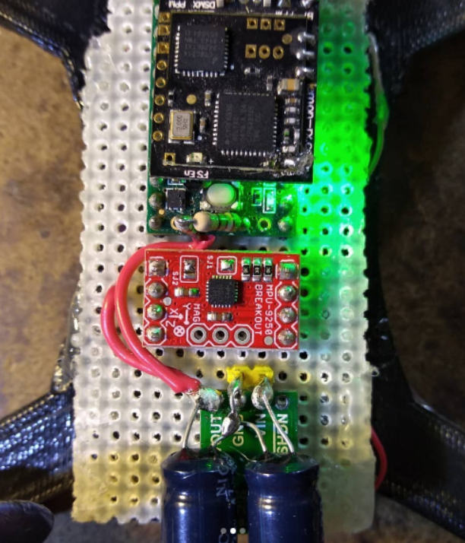

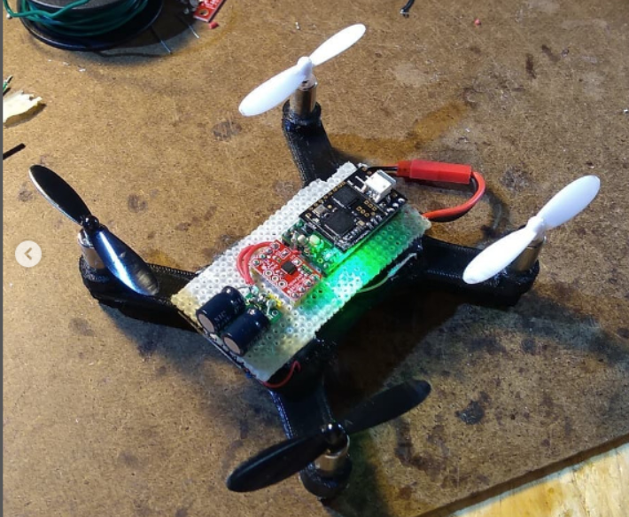

Schematic/PCB prototype already designed: 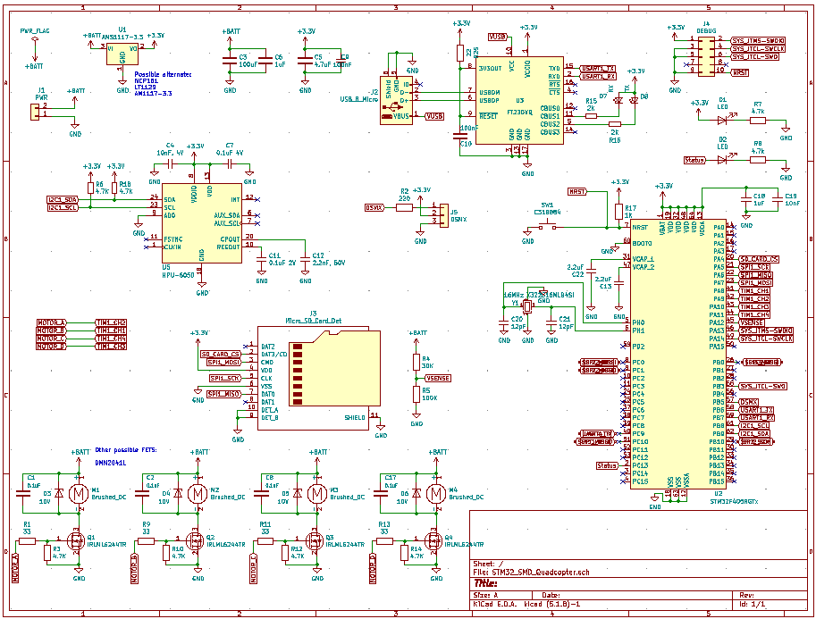

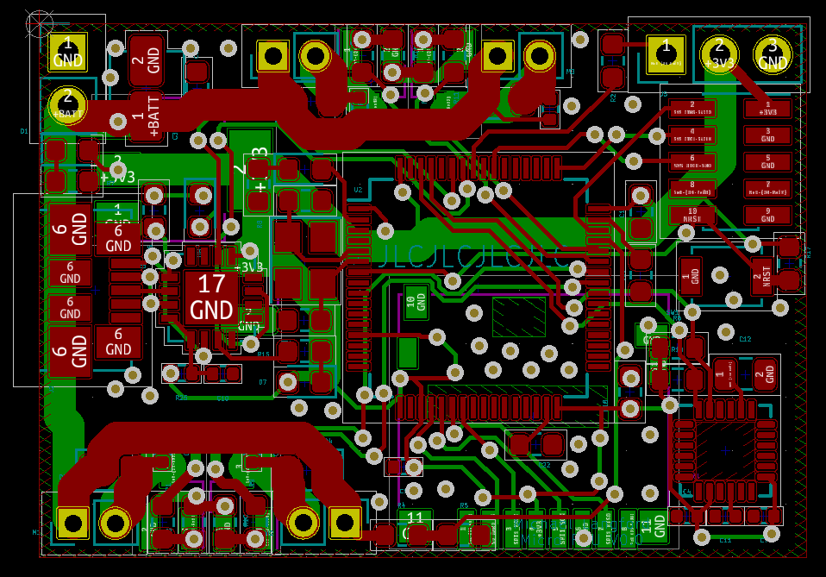

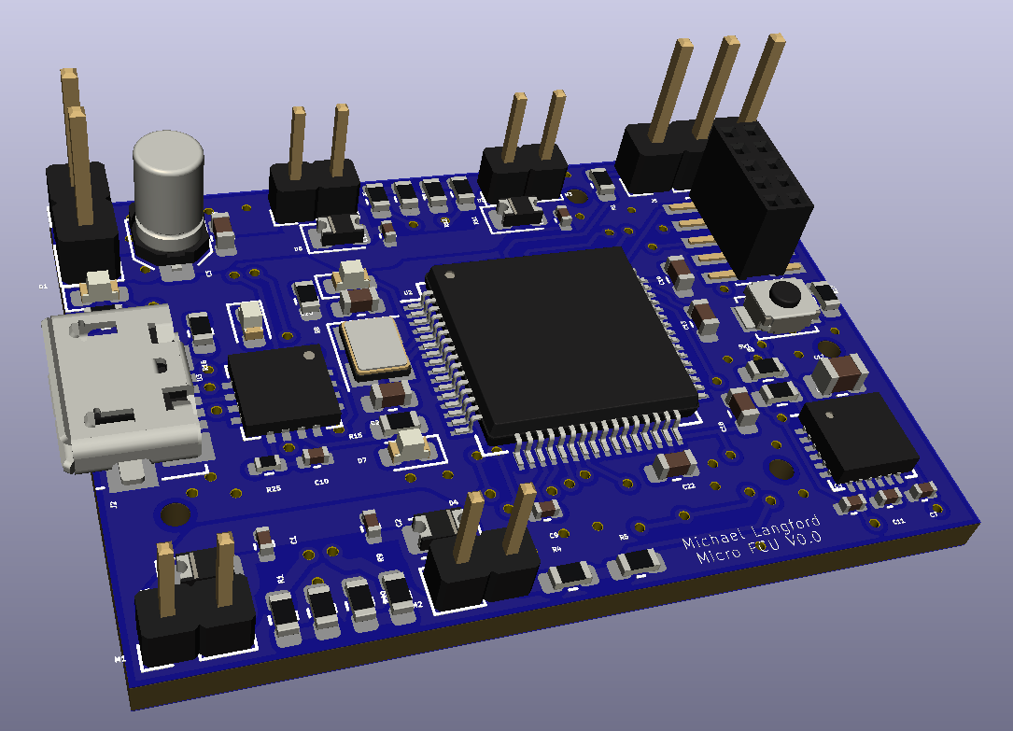

Rough diagram of complete project: